***PAAREES PERFUMES***

***VERSACE***

***FOR MEN***

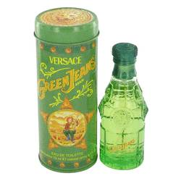

# 

***GREEN JEANS***

## *Description:*

Green Jeans by Versace Cologne. Whether you're hard at work or playing hard, the designer fragrance of Green Jeans for men by Versace leaves you with an unforgettable scent that is sure to get you noticed. Created in 1996, it features the exhilarating combination of lime, lavender, tarragon and petitgrain that develops into an impressive scent to satisfy the most discerning men. Choose Green Jeans whenever you need a striking scent that has the power to carry you no matter what the day has in store.